2015 in Review

Extent of Service:
By expanding the number of learning sites, going to a seven-day-a-week schedule (including four evenings a week), and deploying a record 329 volunteer tutors, we served a record 1,189 adults and children. Of those, 334 were children of immigrants and refugees, 799 were adult English language learners, and 56 were adult basic literacy learners.
Our weekly learning sites jumped from 24 to 34. Among the new sites were manufacturer TMCO, Bryan Health East and Bryan Health West, Park Middle School, Lincoln High School, and New Hope United Methodist Church.

Programs:
To close the budget gap while expanding services, we focused on adding sites that would generate income for us as well as serve people in need. TMCO, Bryan Health, and Park Middle School are all instances of this. Each pays Lincoln Literacy to come in and provide services. However, pursuit of income is never our chief motive; with no prospect of funding we also added a Sunday afternoon class at the F Street Recreation Center and van service for our Friday classes at Good Neighbor Center.
Our joint initiative at Lincoln High with Southeast Community College (SCC) marks a genuine innovation in service delivery. We have long partnered with SCC in teaching
refugees, but until now each institution has taught in its own way. Typically, SCC provides intense, month-long instruction for newly arrived refugees and then passes them on to Lincoln Literacy for longer term, less intensive but more personalized instruction. With the Lincoln High, program, however, we blended services: SCC provides curriculum and supervision, LL provides staff and volunteer tutors, and both organizations recruit refugee parents with children enrolled at the school. The aims of the three-nights-a-week class are to teach English but also to empower the parents to get involved in their children’s education. To date, 11 refugee parents have taken part in the classes.

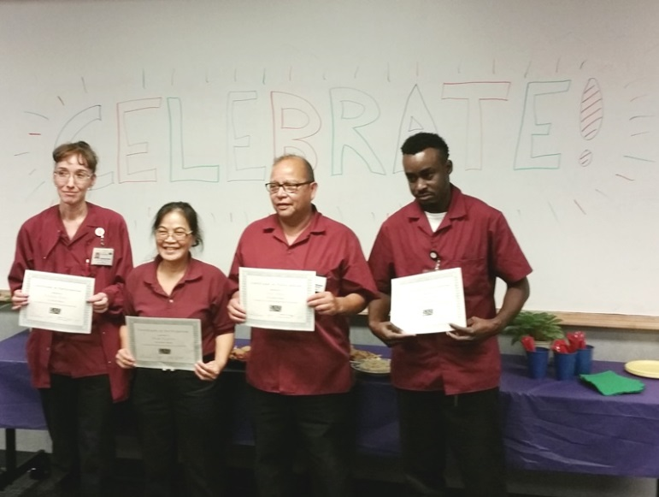
Outcomes:
We had many reasons to be pleased (though not complacent) with the results of our efforts. Learners of all ages made significant gains in our programs. Among children, 85 percent demonstrated school readiness skills and 82 percent gained on literacy assessments. Of 203 children we observed, 93 percent also demonstrated positive social and emotional interactions with peers and adults.
Among adult English language learners (N=799), of those post-assessed (N=153), 83 percent made measurable gains on the Basic English Skills Test (BEST), with an average advance of 0.92 levels on an 8-level scale.
Members of the housekeeping staff at Bryan Health West who completed our fall English language classes there.
Among adult basic learners, that is speakers of English (N=56), of the 22 who were post-assessed, half made measurable gains, with an average increase of 0.6 on the Test of Adult Basic English (TABE). Adult basic learners are a group that typically lags in achievement, largely because by definition they have experienced profound failure in their prior educational experience and because a significant portion have learning disabilities. In that context, though we aim for two-thirds to show progress, seeing 50 percent make gains is good,.
Just as important to us as objective test score gains is participant satisfaction. Here we were pleased to find that both learners and tutors had good experiences. Satisfaction, expressed in anonymous surveys, was phenomenally high. Among 129 adult students who responded to a simple survey designed especially for them, 98 percent said they like their classes, and 100 percent said their like their tutors. Of the 80 volunteer instructors who responded to an anonymous online survey conducted in early Jan. 2016, 95 percent expressed satisfaction with their tutoring experience. Additionally, 57.5 percent of tutors reported that their students were developing job skills, and 37.5 percent reported that their students had actually landed jobs.

Fundraising and Finances:
During 2015 Lincoln Literacy had its most successful fundraising year ever. It began with finishing 6th among 327 nonprofits competing for donations on Give to Lincoln Day (May 28, 2015). In 24 hours, Lincoln Literacy received some $60,000, up from $42,000 the year before. While that remained the high point, unlike previous years contributed income remained strong throughout the year. Our Reading Rainbow dinner in the spring brought in $20,000, and our Scrabble Scramble tournament in the fall raised $17,000. The annual appeal at year’s end brought in an additional $30,000. On top of all that, we received our first-ever legacy gift of $78,000 left to us by former volunteer tutor Helen Roeske. (The board has restricted those funds for long-term investment.) In sum, during 2015 we raised $204,924 in contributions. Net of the estate gift, that total came to $126,875, up 59 percent from the year before. We finished the year with a surplus of $22,903 in unrestricted funds. We will send you a copy of our 2015 audit when it is completed, around mid-to-late April.

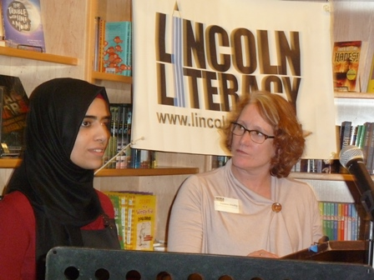
Public Engagement:
Throughout the year we made outreach efforts to the public. Our use of social media – especially Facebook – proved highly effective. We passed 500 likes during the year. Our mass emails helped to bring people into our events.
As refugee resettlement became more controversial, we organized a Refugee Read-a-thon with Indigo Bridge Books, an independent nonprofit bookstore. The event, held Sunday, Dec. 6, was livestreamed on the web.
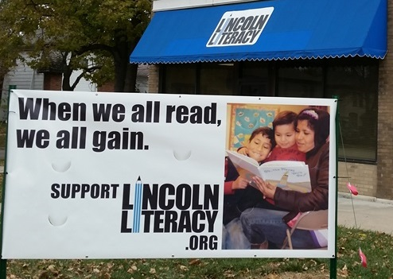
We ventured into advertising toward the end of the year, with the purchase of a banner that we erected outside our headquarters.
Finally, in light of the executive director’s tenth anniversary on the job, we were able to solicit interest from L Magazine, which put Lincoln Literacy on the cover of its December issue and ran an excellent feature story about us, our volunteers, and the people we serve.

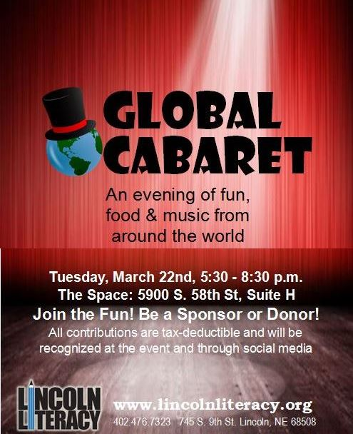
Plans for Future and Challenges Ahead:
After rapid growth in services over the last year, the board has directed management to focus on consolidation and quality for the time being. This does not mean that no new services will be provided, but as an organization we do not want to sacrifice what’s best about our services –the staff’s work to train, equip, and engage with volunteer tutors, the personal attention of trained volunteers, and the support services that enable anyone to attend – for the sake of sheer volume.
That said, we are looking into the feasibility of building on the model provided by our joint class with SCC. If we can muster the staff and funds, we hope to offer a 10-hour-week class for refugees receiving Temporary Assistance for Needy Families. This would enable them to meet the educational requirements for benefit eligibility.
In view of the threat posed by loss of federal refugee social service dollars, we are continuing to step up efforts to garner community support. We have a new fundraising event planned for this spring: the March 22nd Global Cabaret, featuring food, music, and other entertainment from around the world. We’re also working hard to recruit strategically to our board. We’re soliciting former refugees who have made good in the community, business leaders, and education leaders.
Despite our successes in 2015, simply raising enough funds to meet our budget this year remains a formidable challenge. The nonprofit community in Lincoln is growing fast, and there are some who are encroaching on what we like to think of as our special territory: language and literacy services. To succeed, we must continue not only to do good and worthwhile work but seen to be doing it and appreciated for what we do.

